**Degrees of freedom**

Degree of freedom means how many variables are required to determine position of a mechanism in space. The system's DOF is equal to the number of independent parameters (measurements) which are needed to uniquely define its position in space at any instant of time.

For a rigid body in 2D space, 3 parameters can be used to define an object. For example, a pencil placed in 2D space can be defined to have 2 coordinates for its position (of any point on the pencil) and one angular coordinate for angle of pencil with axes. Then the pencil is said to have 3 DOF. If the pencil is placed in 3D space, then it requires six parameters to define its Degree of Freedom. Any rigid body in three-space has six degrees of freedom. It is assumed that rigid body is incapable of deformation for the purpose of kinematic analysis.

In a two-dimension plane, an object can experience multiple motions, which can be classified into- Rotational and Translational motion. In pure rotation motion, object experiences only rotation about its reference axis. In translational motion, all points on the object describe a parallel path and move in parallel motion, without changing its angle about the axis. If an object changes its position about the reference axis in both translational and rotational motion, then it is described as a complex motion. In mechanics, there are three types of linkage design to carry out these motions: Binary link, Ternary link, Quaternary link. They contain nodes for point of attachment to other links to form joints. Joints can be classified by the number of degrees of freedoms they allow between the two elements joined.

A mechanism is a collection of rigid bodies or links, connected through pairs, provided one link is grounded. If a system was not connected like this, then each link except the ground would have 3 degrees of freedom. So total degrees of freedom, or mobility is 3(N-1). N represents total number of links. When we connect it together through pairs, links will not have the same 3 degrees of freedom. If joint between 2 links is having surface contact, then both the links will have same translatory motion, in X and Y directions. So, for each such pairs, there will be a deduction of 2 mobility from total mobility. Such pairs are called lower pairs. If joint between 2 links is having line or point contact, both the link should have same translational motion along the common normal. However, it could have different motion, in tangential direction. So, for each such pairs, there will be deduction of 1 mobility from total mobility.

One freedom joint commonly used in planar mechanisms, can show two forms of joints, rotating pin joint and translating slider joint. They are also called full joints and are lower pair joints (meaning they have a surface contact). Rotating pin joint allows rotational motion of 1 DOF and slider pin for translational motion of 1 DOF.

Helical joint, Revolute Joint, and prismatic joint are also examples of 1 DOF joints.

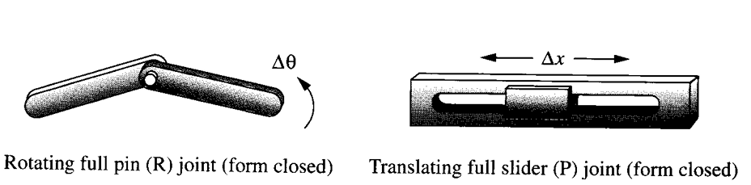

two-freedom joints which simultaneously allow two independent, relative motions, namely translation and rotation, between the joined links. This two-freedom joint is sometimes referred to as a "half joint," with its two freedoms placed in the denominator. The half joint is also called a roll-slide joint because it allows both rolling and sliding.

A cylindrical joint is a 2 DOF joint

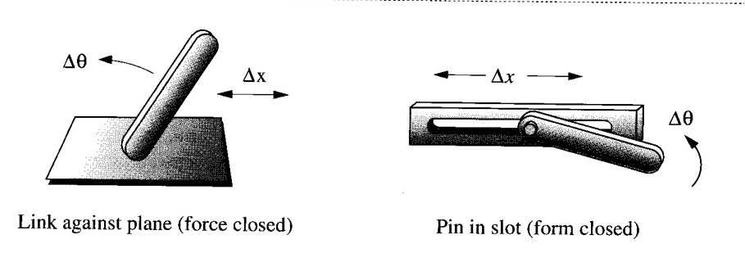

A spherical, or ball-and-socket joint, is an example of a three-freedom joint, which allows three independent angular motions between the two links joined. This ball joint would typically be used in a three-dimensional mechanism, one example being the ball joints in an automotive suspension system.

Both are higher pairs resulting in more Degrees of Freedom. Lower pairs are often closed, meaning they remain in contact without external force, whereas higher pairs are often open and require an external force to maintain contact, such as gravity or a spring.

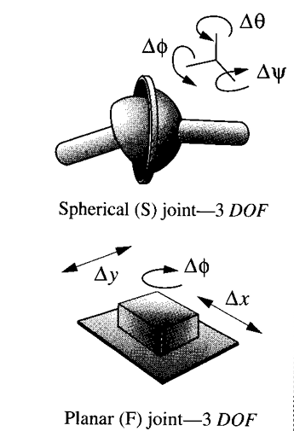

The general equation to find out degrees of freedom of a planar mechanism is known as Kuthbach equation.

**D.O.F = 3(N - 1) -2L P - HP**

Here N represent total number of links in the mechanism. LP and HP represent number of lower pairs and higher pairs respectively.

Another classification of joints is Form closed and Force closed joints. A form-closed joint is kept together or closed by its geometry. A pin in a hole or a slider in a two-sided slot is form closed. A force-closed joint, such as a pin in a half-bearing or a slider on a surface, requires some external force to keep it together or closed. This force could be supplied by gravity, a spring, or any external means. In linkages, form closure is usually preferred, and it is easy to accomplish. But for cam-follower systems, force closure is often preferred.

Order is defined as the number of links joined minus one. It takes two links to make a single joint; thus the simplest joint combination of two links has order one. As additional links are placed on the same joint, the order is increased on a one for one basis. Joint order has significance in the proper determination of overall degree of freedom for the assembly. A machine is a collection of mechanisms arranged to transmit forces and do work.

Another definition of Degree of Freedom is the number of inputs which need to be provided in order to create a predictable output. The number of inputs needed to obtain that output may or may not be specified. Cost is the principal constraint here. Each required input will need some type of actuator, either a human operator or a motor, solenoid, air cylinder, or other energy conversion device. These multiple input devices will have to have their actions coordinated by a "controller," which must have some intelligence. This control is now often provided by a computer but can also be mechanically programmed into the mechanism design. Some machines have many DOF. Example – Bulldozer or a crane.

**DOF IN PLANAR MECHANISMS:**

To determine the overall DOF of any mechanism, we must account for the number of links and joints, and for the interactions among them. The DOF of any assembly of links can be predicted from an investigation of the Gruebler condition. Any link in a plane bas 3 DOF. Therefore, a system of L unconnected links in the same plane will have 3L DOF.

Two unconnected links have a total of six DOF. When these links are connected by a full joint, this removes two DOF, leaving four DOF. Connection with the half joint removes only one DOF from the system (because a half joint has two DOF), leaving the system of two links connected by a half joint with a total of five DOF. In addition, when any link is grounded or attached to the reference frame, all three of its DOF will be removed. This reasoning leads to Gruebler's equation:

M=3L-2J-3G

Where:

M=Degree of freedom or mobility

L= Number of links

J=Number of joints

G=Number of grounded links

However in real mechanisms, net effect will be to create one larger, higher-order ground link, as there can be only one ground plane. Thus G is always one, and Gruebler's equation becomes:

M=3(L-1)-2J

When Kutzbach’s modification is used in Gruebler’s equation, as half joints only count as half as they remove 1 DOF, it becomes:

M=3(L-1)-2J1-J2

Where J1 is number of 1 DOF in full joints and J2 is number of 2 DOF in half joints

**STEWART PLATFORM**

Stewart platform is a 6 DOF mechanism that consists of a rigid plate. The plate at the base of the Stewart device is the only static part of the device. This plate is attached to the floor or another surface preferably with the help of bolts. Its six legs connect the base plate to the moving top plate. To provide an ample range of motion, different types of joints are used on both ends of the legs. Often each leg has a cylindrical shell and the length of each leg can be changed as needed.

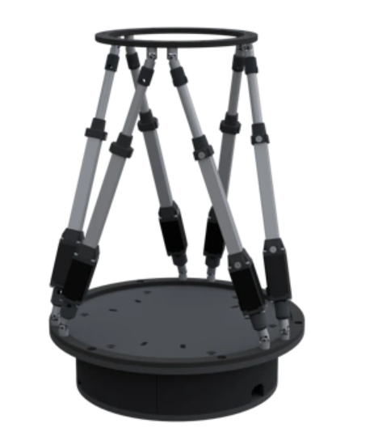

It consists of two layers: one fixed and one movable, connected by six legs that can change in length. Usually, hydraulic jacks or electric linear actuators are used for the “legs.” The legs can be fixed to three to six mounting points on the top plate and similarly on the platform's base plate. The Stewart Platform mechanism is designed to make translational movements in three directions and rotational moves in three ways depending on the angle of the joints and the leg lengths. To achieve a six DOF mechanism, at least one spherical joint is required on each leg whereas the other joint can be either a universal or spherical joint. To convert the Stewart platform into a force sensor, the same joint configuration is required to ensure that the deformations in the legs are purely axial.

Although parallel robots are used in the machinery sector, they are also used for applications such as Engineering Research Applications, Training simulators for air, sea, and land vehicles, Medical and Surgical Applications, etc.